The charts below show the results of a survey about what people of different age groups say makes them most happy.
Summarise the information by selecting and reporting the main features, and make comparisons where relevant.
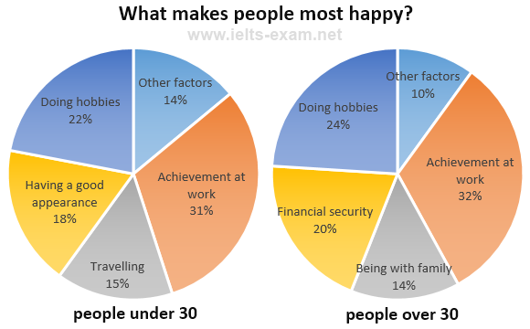

Model answer
There are several similarities between what younger and older people say makes them most happy. However, there are several striking differences.
Firstly, let us look at the similarities. It is noticeable that for both younger and older people, the highest percentage says that achievement at work brings them most happiness: 31% for the younger age group and 32% for the older group. Doing hobbies is also very important for both groups: the second largest percentage of both age groups mention doing hobbies as making them most happy.
Turning now to the differences, many younger people regard having a good appearance as extremely important: 18% of them state this brings them most happiness. This is followed by 15% who state that travel brings them happiness. Neither of these two factors is mentioned by older people. Instead, 20% of older people report that having financial security is most important to their happiness and 14% say they feel most happy when they are with their family.
(163 words)
The pie charts indicate the results of the survey about what makes people happy by dividing people`s age. In general, it seems both pie charts have some similarities and differences.
For both charts, the highest percentage of the factor that makes them happy was work achievements for under 30 and over 30 people, 31% and 32% respectively. Moreover , 22% of people who are under 30 said that when they`re doing their hobbies they feel most happy. It is clear to notice that almost same amount of people (22%) who is over 30 say that they feel happiness from their leisure time activities.
On the other hand, having a good appearance 18%, travelling (15%) and other factors (14%) are most important for people under thirty`s happiness. In contrast, for people over 30, financial stability 20%, and being with family (14%) become the reasons of their happiness.
Overall, it is important to note that work and hobby are most essential happiness source for any age people. However, good looking and travelling are the second crucial reason for young people. By comparison, for people who are over 30, financial security and family are significantly important factor of their happiness. 196

The pie chart gives information on UAE government spending in 2000. The total budget was AED 315 billion.
Summarise the information by selecting and reporting the main features, and make comparisons where relevant.

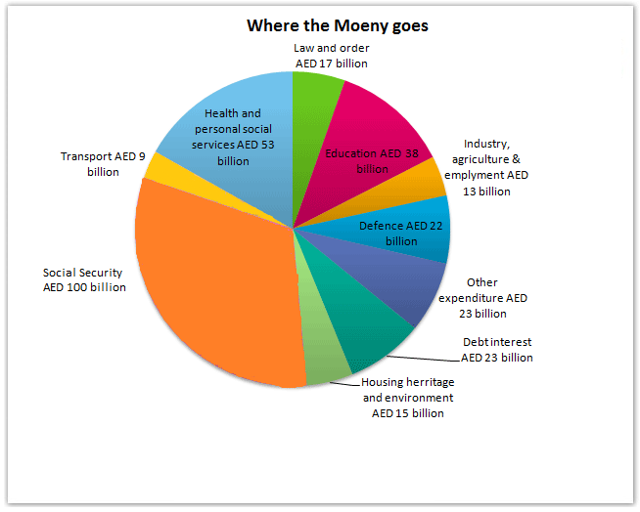
Model Answer 1:
The pie chart shows the UAE government’s budget spending in different sectors in 2000. As is presented, the UAE government had AED 135 billion budget for the year 2000 and they used the highest amount for ensuring social security.
According to the pie chart, the UAE administration allocated AED 100 billion in social security from their national budget of AED 315 billion. This single sector cost the UAE government almost one-third of the total budget. This year the government's expense was 53 million on health and personal social services, which was the second largest sector in terms of expenditure made by the UAE government. 38 million AED was spent on education while 23 billion both in debt and other expenditures.
The government used 22 billion in Defence sector while 13 billion for the industry, employment and agriculture sectors. The lowest amount of money, only 9 billion, went to the transport sector. Finally, 15 billion of the budget was spent on housing and environment.
In summary, UAE government's maximum spending went in social security and healthcare sectors while the least amounts were spent on transport, law and order, housing and industry/agriculture and employment sectors.

Model Answer 2:
The pie chart illustrates the expenditure of the UAE government from the national budget 315 billion AED in 2000. It also shows the segments of expenditure of the UAE administration in different sectors in the same year.
At a first glance, it is crystal clear that the biggest slice of the budget was devoted to social security, AED 100 billion. UAE spent 53 billion on health and personal social services followed by education with 38 billion. However, the least amount of budget was spent on the transportation system, AED 9 billion.
Moving further, it is vivid that debt interest and other expenditure accounted for AED 23 billion of the budget. The expenditure of the UAE budget was 15 billion on housing heritage closely followed by industry, agriculture and employment with AED 13 billion.
Overall, it can be deduced that the least amount of money was spent on transport while the highest amount on the social security by the UAE government in 2000.
[Written by - Kuljeet Sandhu ]

Sample Answer 3:
The pie chart delineates how the UAE administration spent the national budget in 2000. It is obvious that social security and health and personal social services received the largest proportion of incentives from the 315 billion Dirham' national budget in this year in the United Arab Emirates.
As is presented in the diagram, the UAE administration’s budget in 2000 was 315 billion Arab Emirates Dirham and 100 billion of it went on maintaining citizens’ social security. Just over 53 billion was allocated for the health and social services which was the second largest allocation by the USA government. Budget allocation for education, defence and debt interests were 38, 22 and 23 billion Dirhams respectively. Housing heritage and environment sector was allotted 15 billion Dirham which was 6 billion higher than the allocation for transportation. The UAE government shared only 9 billion Dirham, the least, for its transportation sector in 2000 while other expenditure accounted for 23 billion.

https://www.ielts-mentor.com/writing-sample/academic-writing-task-1/992-academic-ielts-writing-task-1-sample-58-the-pie-chart-gives-information-on-uae-government-spending-in-2000

