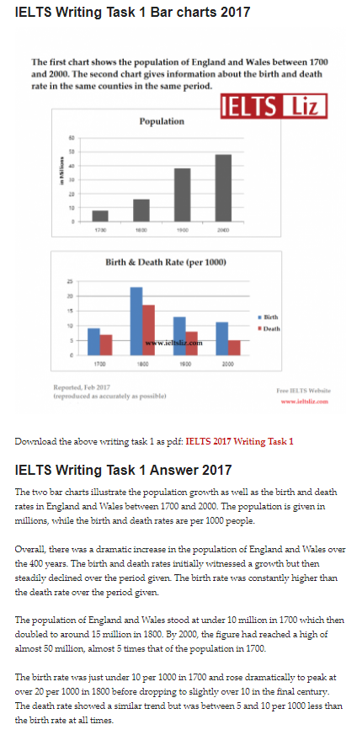https://ieltsliz.com/ielts-writing-task-1-answer-2017/

Write at least 150 words.
Writing task Change in workforce (15 marks)
The bar chart shows changes in the workforce and population of a country over a 30-year period.
Summarize the information by selecting and reporting the main features. Write at least 150 words.
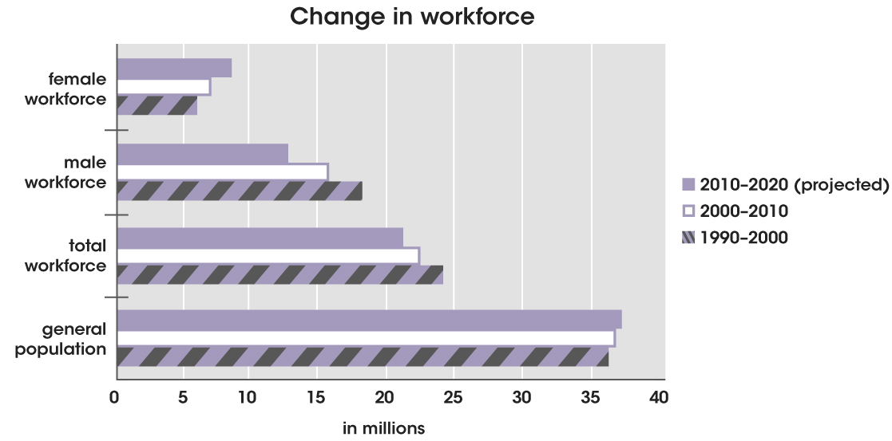
Change in workforce
Model answer:
The bar chart shows how the workforce changed in terms of gender from
1990 to 2010, and how it is expected to change up to 2020. It also shows the
changes in the makeup of the general population, both actual and projected.
Figures are given in millions.
It can be seen that while the general population has increased only slightly,
the male workforce has declined while the female workforce has increased,
and this is projected to increase further.
At the start of this period, the size of the female workforce was about a
third the size of the male, with six million compared to 18 million workers.
By 2000, the female figure had grown to almost half the size of the male,
with seven million female and just over 15 million male workers. The gap
is expected to continue to narrow, with projected figures of eight million
females and around 12 million males by 2020.
Overall, the total workforce is in decline and is expected to continue this
trend, with figures of 24 million reducing to an estimated 21 million.
However, the total population increased from around 35 to 36 million from
2000 to 2010, with a further increase of about a million expected by the year 2020.

stacked bar chart
The bar chart shows changes in weight among inhabitants of Charlestown in 1955 and in 2015
Summarize the information by selecting and reporting the main features. Write at least 150 words.

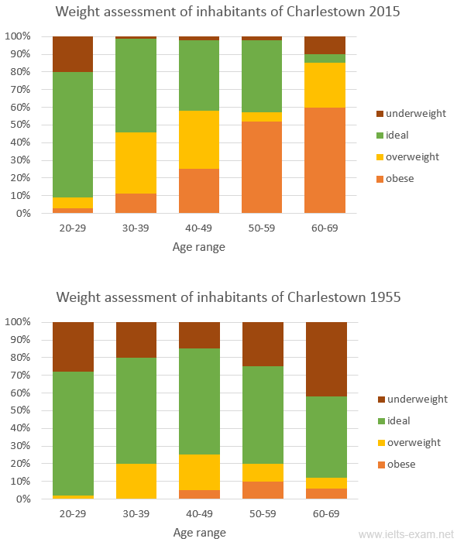
Read the model answer below, and choose the correct alternative for each gap.
Model answer 1
The charts provide an analysis of the weight issues among the residents of the town of Charlestown in 1955 and in 2015.
In 1955, the youngest age group had the fewest number of weight issues, with more than 70% of 20-29-year-olds being assessed as having a healthy weight. In the same year, excess weight was only a significant problem among 40-49-year-olds, 20-30% of whom were classified as either overweight or obese. In fact, being underweight was a more significant problem affecting more than twenty percent of each age group, and the elderly in particular, with 40% of the over 60s being classified as underweight.
In stark contrast to this, in 2015, being underweight was only a problem among 20-29-year olds, with 20% obtaining this diagnosis, and the number of underweight elderly people had fallen to 10%. The charts clearly show that, in modern times, obesity poses a considerable problem from the age of 30 upwards. In fact, there was a steady increase in this problem in almost every age group over 29 until the age of 60, when the vast majority are considered to have an unhealthy weight. It is important to note that, by the age of 60, less than 50% of each age group was considered to have a perfect weight by the year 2015. This is a fall of 10% compared to the same age group in 1955.
When comparing the two years, it is clear that there has been a significant increase in the number of obese people in Charlestown, and there was a general drop in the number of underweight people between 1955 and 2015.
https://www.ielts-exam.net/academic_writing_samples_task_1/1005/
Model answer 2
The charts provide a summary of the percentage in 1955 and six decades later of Charlestown residents in terms of body weight.
Overall, people of all age groups with ideal weight made up the bulk in 1955, while in 2015 most of the population aged above 40 were either overweight or obese. Underweight people, on the other hand, were less common in 2015 compared to 60 years ago.
In both years, 70% of people in their twenties had ideal body weight. However, the proportion of the town’s inhabitants of this category aged 60-69 had dropped from well under 50% to just 5%. 6 decades later, underweight residents, on the whole, also had reduced in numbers, to almost close to zero among those aged 30-59.
In complete contrast, the overweight and obese had increased dramatically in 2015, particularly among people of middle and old age. For the first time, obesity was seen among people 20 to 39 years old in 2015. While marginally less than 10% of youngsters in their 20s weighed heavier than normal or were obese, the percentage of people aged between 60 and 69 had rocketed from over 10% to 85%, with 60% categorized as obese and 25% as overweight.

